**loanable funds market[1].** The price that is determined in the loanable funds market is the interest rate, denoted by *r.*



How savings and investment get matched up? The interest rate at which the quantity of loanable funds supplied equals the quantity of loanable funds demanded is called the **equilibrium interest rate.** In equilibrium, the quantity of funds that savers want to lend is equal to the quantity of funds that firms want to borrow.



The credit supply curve and the credit demand curve complete the credit market, where borrowers obtain funds from savers. It is sometimesreferred to as the **loanable funds marke**t.

We’ve simplified the credit market by assuming that different borrowers all have identicalrisks of defaulting on their loan. In other words, all borrowers have the same risk of not repayingtheir loan. This simplification implies that there will be a single equilibrium real interestrate in the credit market. (In actual markets, borrowers with different risks of defaulting facedifferent real interest rates to compensate lenders for these differential default risks.)Like other markets represented by a supply curve and a demand curve, the equilibriumin the credit market is the point at which the curves intersect.

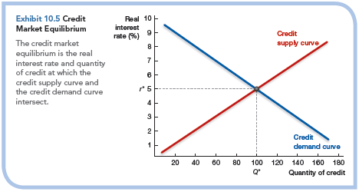

**Two Alternative Theories for Interest Rate Detemination: Liquidity Preference and Loanable Funds:**

One view says that the interest rate is determined by the supply of and demand for savings – the “**loanable funds**” approach. The other says that the interest rate is determined by the tradeoff between bonds, which pay interest, and money, which doesn’t, but which you can use for transactions and therefore has special value due to its liquidity – the “**liquidity preference**” approach.

Start with the loanable funds side. Suppose that desired savings and desired investment spending are currently equal, and that **something causes the interest rate to fall**. Must it rise back to its original level? Not necessarily. **An excess of desired investment over desired savings can lead to economic expansion, which drives up income. And since some of the rise in income will be saved.**  Equality between desired savings and desired investment at the new interest rate.

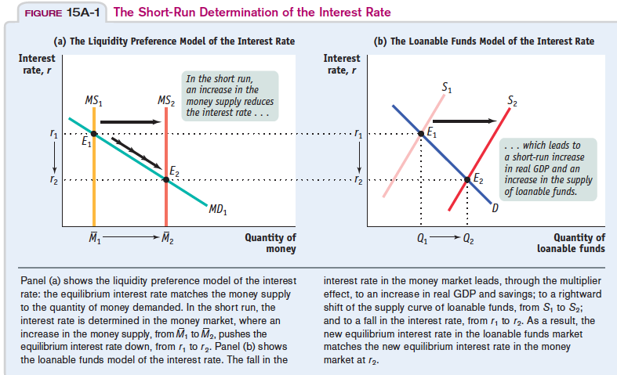

**Money Market Under the Condition of Liquidity Trap**

**Interest rates may be insensitive to changes in the money supply (liquidity trap).**

**Liquidity Trap** is represented by the **horizontal portion of the money demand function**. When interest rates get so low **that no one thinks they can get any lower**, so no matter how much money the Fed throws into the system, people just hold onto it, **waiting for interest rates to rise**

**Mostly interest rate cannot go below zero**, a constraint known as the **zero lower bound**. When the interestrate is down to zero, monetary policy cannot decrease it further. Monetary policy no longerworks, and the economy is said to be in a **liquidity trap**.Ten years ago, the zero lower bound was seen as a minor issue. Most economists believethat central banks would not want to have negative interest rates in any case, so the constraintwould be unlikely to bind. The crisis however, has changed those perceptions. Manycentral banks decreased interest rates to zero and would have liked to go down even further.But the zero lower bound stood in the way, and turned out to be a serious constraint on policy.

**When we derived the demand for money we did not ask what happens when the interest rate becomes equal to zero.**Now we must ask the question. The answer: **Once people hold enough money for transactionpurposes, they are then indifferent between holding the rest of their financialwealth in the form of money or in the form of bonds. The reason they are indifferent isthat both money and bonds pay the same interest rate, namely zero**. Thus, the demandfor money is as shown in following figure As the interest rate decreases, people want to hold more money (and thus fewer bonds): The demand for money increases. As the interest rate becomes equal to zero, people want to hold an amount of Money at least equal to the distance, *OB*. This is what they need for transaction purposes. But they are willing to hold even more money (and therefore hold fewer bonds) because they are indifferent between money and bonds. Therefore, the demand for money becomes horizontal beyond point *B*.

Now consider the effects of an increase in the money supply. (Let’s ignore banks for he time being, and assume, as in all money is currency, so we can use the same diagram as in Figure extended to allow for the horizontal portion of Money demand. We shall come back to banks and bank money later.) Consider the case where the money supply is *Ms*, so the interest rate consistent with financial market equilibrium is positive and equal to *i*. (This is the case we considered before.Starting from that equilibrium, an increase in the Money supply — a shift of the *Ms* line to the right — leads to a decrease in the interest rate. Now consider the case where the money supply is *Ms*_, so the equilibrium is at point*B*; or the case where the money supply is *Ms*_, so the equilibrium is given by point *C*.In either case, the initial interest rate is zero. And**, in either case, an increase in themoney supply has no effect on the interest rate.** Think of it this way:Suppose the central bank increases the money supply. It does so through **anopen market operation in which it buys bonds and pays for them by creating money**.As the interest rate is zero, people are indifferent to how much money or bonds theyhold, so they are willing to hold fewer bonds and more money at the same interestrate, namely zero. The money supply increases, but with no effect on the interestrate — which remains equal to zero.What happens when we reintroduce checkable deposits and a role for banks,along the lines of Section 4-3? Everything we just said still applies to the demand formoney by people: If the interest rate is zero, they are indifferent to whether they holdmoney or bonds: Both pay zero interest. But, now a similar argument also applies tobanks and their decision whether to hold reserves or buy bonds. If the interest rate isequal to zero, they will also be indifferent as to whether to hold reserves and to buybonds: Both pay zero interest. Thus, when the interest rate is down to zero, and thecentral bank increases the money supply, we are likely to see an increase in checkabledeposits and an increase in bank reserves, with the interest rate remaining atzero. As the Focus box “The Liquidity Trap in Action” shows, this is exactly what wesaw during the crisis. As the Fed decreased the interest rate to zero, and continued toexpand the money supply, both checkable deposits by people and reserves by bankssteadily increased.

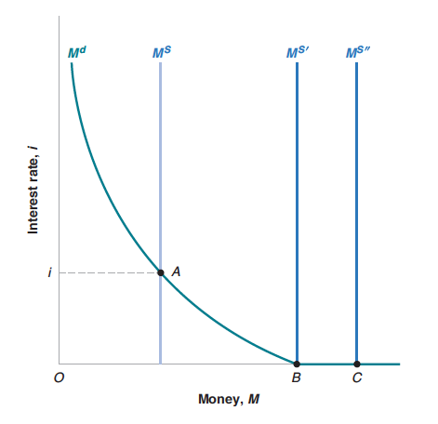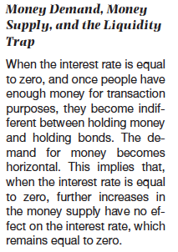

When the crisis started, the Fed tried to limit the decrease in spending by decreasing the interest rate it controls, the so-called *federal funds rate*. As you can see from figure. The federal funds rate went from 5.2% in July 2007 to nearly 0% (0.16% to be precise) in December 2008.Why did the Fed stop at zero? Because the interest rate cannot be negative. If it were, then nobody would hold bonds, everybody would want to hold cash instead—because cash pays a zero interest rate. This constraint is known in macroeconomics as the *zerolower bound*, and this is the bound the Fed ran into in December 2008.



This sharp decrease in the interest rate, which made it cheaper for consumers to borrow, and for firms to invest, surely limited the fall in demand and the fall in output. But, this was not enough to avoid a deep recession: U.S. growth was negative in both 2008 and 2009. To help the economy recover, the Fed then kept the interest rate close to zero, where it has remained until 2015. The Fed’s plan is to start increasing the interest rate soon, so it is likely that the rate will have increased since then but it will still be very low by historical standards. Why are low interest rates a potential issue? For two reasons: The first is that lowinterest rates limit the ability of the Fed to respond to further negative shocks. If the interestrate is at or close to zero, and demand further decreases, there is little the Fed cando to increase demand. The second is that low interest rates appear to lead to **excessiverisk taking by investors**. **Because the return from holding bonds is so low, investors aretempted to take too much risk to increase their returns. And too much risk taking can inturn give rise to financial crises of the type we just experienced.** Surely, we do not want toexperience another crisis like the one we just went through.

Three important economiesexperienced a liquidity trap in the last 100 years: **North America** in the **Great Depression** of the1930s, the prolonged **Japanese** slump of the 1990s, and the **United States** in 2009 as part of theworld economic crisis of 2009. Although these events are rare, the reduction in output in a liquiditytrap is large and long.



* + - 1. **Derivation of LM Curve at Equilibrium Condition of Money Market**

**While investment depends on the real interest rate, money demand depends on the nominal interest rate (Mankiw, 2000, 300; Blanchard, 2011, 297)**. In fixed price IS – LM model, because of the inflation expectation $π^{e}$ is taken as zero, thereby real $r$ and nominal $i$ interest rates would be same.

$$r=i-π^{e}$$

$$if π^{e}=0 then r=i$$

Change in nominal or real interest rate is directed by real demand and real supply of money.

$$\frac{dr}{dt}=\frac{di}{dt}=β\left[\frac{M^{D}}{P}-\frac{M^{S}}{P}\right] 0<β<1$$

Equilibrium condition of money market which is represented by LM curve, can be described as follows.

$$\dot{r}=\dot{\dot{i}}=\frac{di}{dt}=0→\frac{M^{D}}{P}=\frac{M^{S}}{P}$$

Nominal interest rate is determined in money market by the demand for money decided by private side of economy and **supply of money that is managed by monetary authority through the money multiplier and monetary base.**

If the central bank is able to control the money supply, the money supply is “exogenous,” and the money supply curve is vertical.

**Slope of the LM Curve:**





* + - 1. **Derivation of LM Curve under the Condition of Liquidity Trap**



* + 1. **Goods and Money Markets Equilibriums IS-LM Model:**



Consequently standard fixed price IS – LM model can be explained as a two variable differential equation system. According to equation 9b it is preferred to use nominal interest rates.

$$\left[\begin{matrix}\dot{\dot{i}} \\ \dot{Y}\end{matrix}\right]=\left[\begin{matrix}I_{i}+C_{i} & C_{Y}-1 \\ M_{i}^{D} & M_{Y}^{D}\end{matrix}\right]\left[\begin{matrix}i \\ Y\end{matrix}\right]+\left[\begin{matrix}G \\ \frac{M^{S}}{P}\end{matrix}\right] (16)$$

**1.1.4.1. Fiscal and Monetary Multipliers in IS – LM Model**

**Policy Multipliers with Linear Example**



* 1. What is the equilibrium income and interest rate of the economy
  2. Calculate the slope of the IS and LM curves
  3. Calculate the fiscal and monetary multipliers.



a) Calculation to equilibrium values of income level and interest rate;



b)

From the IS relation



Slope of IS curve:



From the LM relation



Slope of the LM relation



c)



**Monetary Policy Multiplier**:





**Fiscal Policy Multiplier:**





**Crowding Out:**

An increases in government budget deficits (government dissaving) cause saving andinvestment to fall in the long run and real interest rates to rise.

$$S^{P}↑=I↓+(\underset{government deficit}{\underbrace{G-T}})↑$$

Because government budget deficits can lead to crowding out of private investmentand higher real interest rates.

**Crowding out**occurs when agovernment budget deficit drivesup the interest rate and leads toreduced investment spending. Crowding out the negative effect ofbudget deficits on private investment,which occurs because **government borrowingdrives up interest rates**.

So, other things equal, a rise in the government budget deficit tends to reduceoverall investment spending. Economists call the **negative effect of governmentbudget deficits on investment spending crowding out.** Concerns about crowdingout are one key reason to worry about increasing or persistent budget deficits.

**However, it’s important to add a qualification here: crowding out may notoccur if the economy is depressed. When the economy is operating far belowfull employment, government spending can lead to higher incomes, and thesehigher incomes lead to increased savings at anygiven interest rate. Highersavings allows the government to borrow without raising interest rates**. **Manyeconomists believe, for example, that the large budget deficits that the U.S. governmentran from 2008 to 2013 in the face of a depressed economy caused littleif any crowding out.**

Crowding out occurs whenexpansionary fiscal policy causes interest rates to rise, thereby reducing privatespending, particularly investment.What factors determine how much crowding out takes place? In other words, what determines the extent to which interest rate adjustments dampen the output expansion induced by increased government spending?

• **Income increases more, and interest rates increase less, the flatter the LM schedule**.

• **Income increases less, and interest rates increase less, the flatter the IS schedule.**

• **Income and interest rates increase more the larger the multiplier,**

In each case the extent of crowding out is greater the more the interest rate increaseswhen government spending rises.

**If the economy is in the liquidity trap, and thus the LM curve is horizontal, an increasein government spending has its full multiplier effect on the equilibrium level of income.There is no change in the interest rate associated with the change in governmentspending, and thus no investment spending is cut off. There is therefore no dampening of the effects of increased government spending on income.**

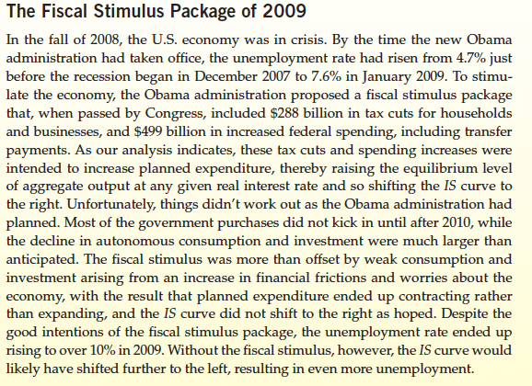

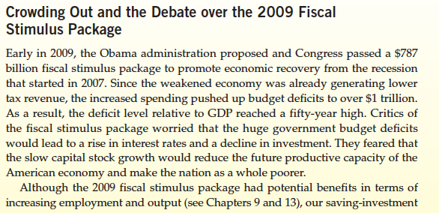

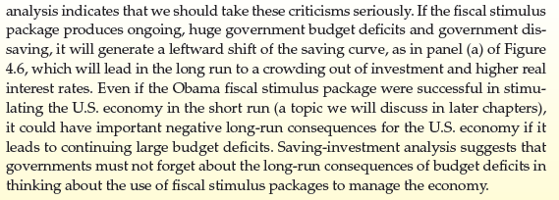

**About the Size of Fiscal Multiplier:**

In February 2009, the U.S. government enacted The American Recovery and Reinvestment Act of 2009 with the **aim of lifting the economy out of the recession**that began in December 2007. This bill, which is often called a **stimulus package, was projected to increase the Federal government’s deficit by nearly $800 billion over the following decade, by reducing taxes by about $300 billion and increasing government expenditures by about $500 billion**

In the IS–LM model, a temporary increase in government purchases shiftsthe IS curve up and to the right), which causes theIS–LM intersection to move upward and rightward also. In the **Keynesian version of the model, prices remain fixed in the short run** and the upward and rightward shift of the IS–LM intersection indicates output increases in the short run. **In the classical version of the model, however, prices adjust quickly, thereby shifting the LM curve up and to the left,** which tends to offset the rightward shift of theIS curve. However, there is an alternative channel by which a temporary increasein government purchases will increase output in the classical model.

It is not an easy matter to calculate the **size of the multiplier** associated withparticular changes in government purchases—even after the fact—**because so other shocks may hit the economy and affect output**. Economist ValerieRamey of the University of California at San Diego evaluated research on thesize of the government spending multiplier performed over the past 40 years.

Multiplier is the short-runchange in output that arises from a one unit change in government purchases. Thegeneral finding of the research that Ramey reviewed is that for a deficit-financedtemporary increase in government purchases, ***which describes part of the 2009 stimulus package***, the **government spending multiplier is likely to be between 0.8and 1.5.**So, a temporary increase in government purchases of $100 billion wouldincrease GDP by between $80 billion and $150 billion.Ramey’s evidence was based on a large number of studies of the governmentspending multiplier in many different situations. But you might think that the**multiplier is higher when the economy is in a recession**, when there are manyunemployed resources, than when it is in an expansion.

In a recent study, AlanJ. Auerbach and Yuriy Gorodnichenko, both of the University of California atBerkeley, examined the government spending multiplier and found the **multiplier is only about 0 to 0.5 in economic expansions** but **much higher, 1 to 1.5, in recessions**.

The impact of **government spending on the economy may also be affected by the response of monetary policy.** Research by Gauti Eggertsson of the FederalReserve Bank of New York finds that the government spending **multiplier may be substantially higher if monetary policy is constrained by being at the zero lower bound** as it has been in recentyears in the United State.

So, the empirical evidence indicates that temporary increases in governmentpurchases can increase output with a multiplier between 0.8 and 1.5. The multiplieris higher if the economy is in a recession rather than in an expansion, andhigher still if monetary policy is constrained by being at the zero lower bound.

**Krugman’s Three Ideas About Liquidity Trap and Crowding Out:**

1.

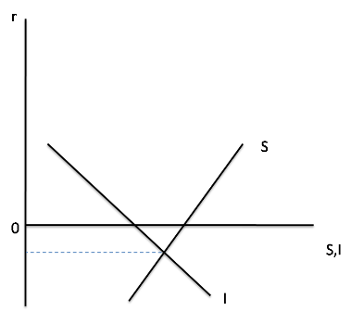

We have an incipient **excess supply of savings even at a zero interest rate**. And that’s our problem. So what does government borrowing do? **It does NOT crowd out private spending,at least not until the excess supply of savings has been sopped up**, which is the same thing as saying not **until the economy has escaped from the liquidity trap**.

2.

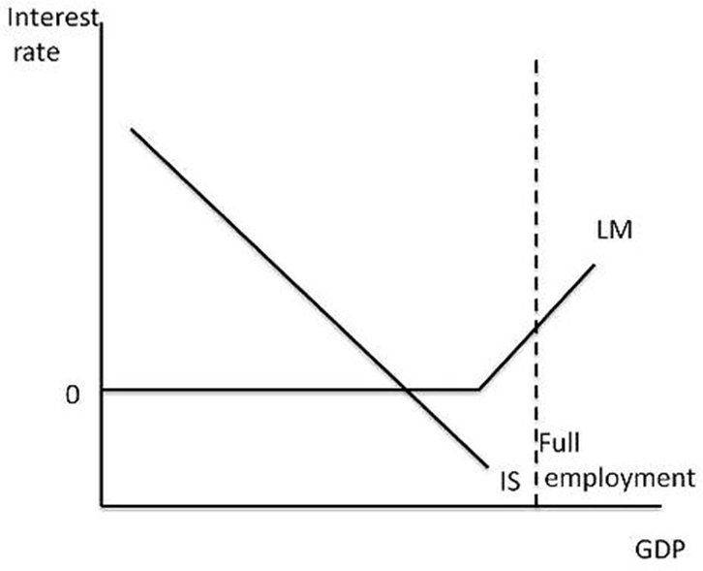

**Economy remains depressed even at a zero interest rate**. In that case the picture looks like this:Why is the LM curve flat at zero? Because if the interest rate fell below zero, people would just hold cash instead of bonds and changes in the money supply have no effect. This is, the **liquidity trap**.

And IS-LM makes some predictions about what happens in the liquidity trap. **Budget deficits shift IS to the right; in the liquidity trap that has no effect on the interest rate.**

That’s why in early 2009, when the WSJ, the Austrians, and the others were screaming about **soaring rates and runaway inflation,**interest rates stayed low and that even a tripling of the monetary base was not be inflationary.

3.

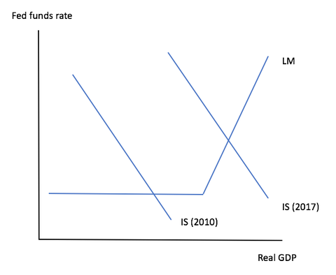

Shift the IS curve in normal circumstances, where the IS curve intersects an upward-sloping LM, such shifts have limited effects on output and employment, because they’re offset by changes in interest rates: fiscal expansion leads to **crowding out**, and multipliers are low.

In the aftermath of the financial crisis, however, we spent an extended period at the ZLB, as shown by the 2010 IS curve. In those conditions, shifts in the IS curve don’t move interest rates**, there is no crowding out** (actually crowding in because **increased sales lead to higher investment**), and multipliers are large. They’re very much exceptional, applying only when interest rates are up against the zero lower bound.

So are we still there? No. Wages are finally rising, quit rates are back to pre-crisis levels, so we seem to be **fairly close to full employment, and the Fed is raising rates**. So it **now looks like the “2017” IS curve in the figure.** We’re just barely over the border into normality, which is why I think the Fed should hold and we could still use some fiscal stimulus for insurance, and very low rates still make the case for lots of infrastructure spending. But it’s not the same as it was.





* + - 1. **Analysis of Policy Implications With IS – LM Model**







**1.1.4.3. Alternative IS – LM Model with Policy Interest Rate**

|  |  |
| --- | --- |
|  |  |
|  |  |
|  |  |
|  |  |
|  |  |
|  |  |
|  |  |

* + - 1. **Finance Motive for Money Demand and Interaction Between the IS an LM Curves.**

Although money demand has been defined a function of national income and interest rate. It will be more appropriate to relate the money demand to consumption and investment, instead of national income.

Davidson (1965) adds money demand with ‘finance motive’ as the forth factor that affects money demand, besides the Keynes’ transaction, precaution and speculation motives, as a subfactor of the transaction motive. As a result of this, **money demand will also be sensitive to (especially planned) consumption and investment spending.** Therefore, money demand can be reformulated with Davidson’s (1965) these suggestions.

$$M^{D}=\left(\underset{+}{\underbrace{C,I}},\underset{-}{\underbrace{i}}\right)$$

By the equation, **goods and money markets are related to each other**.

Besides, money supply is exogenous in the Davidson’s model, therefore, an increase in the investments (*for example due to an optimistic future beliefs about expected profit which is called as animal spirit)* will increase the money demand and will result in a rise in the interest rate level.

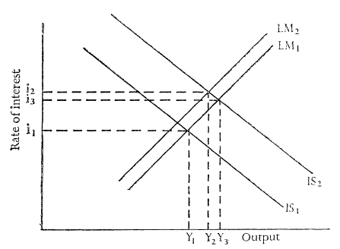

Suppose an outward shift of the investment demand function is posited that at each rate of interest, IS function moves outward to IS2 whereas in standart (Hicks-Hansen's) system, the LM function would remain unchanged when the IS curve shifts, but according to finance motive LM curve also moves to (up) with increasing money (credit) demand to finance aditional investment Thus, the whole LM function shifts upward to so that the new equilibrium level of output and rate of interest (Y2 and i2, respectively) are respectively lower and higher than before.

Since this money demand is met by the credit demand from the banking system, it is now time to add the credit concept into our model.

Then, how the money market will respond the money demand in the form of credit demand must be explained. The standard model in which money supply is determined completely exogenously by the central bank is insufficient in this point. Central bank can give credit ($L^{CB}$) to the banking system if it does not want the interest rate to be increased, but it is needed to explain the role of the banking sector. This problem will be solved in the sections to come, by regarding it (banking sector) as a separate sector as households and firms.

* + - 1. **IS – LM Model with Credit (Loanable Funds Market) Markets: *Bernanke Blinder Model***



Macroeconomics gained a new toolbox for analysing the effects of monetary policy on the real economic variables, when Bernanke and Blinder (1988)**introduced the credit mechanism into the standard IS-LM model,** by considering money and bank credits together in their aggregate demand framework. Then their model has augmented with the assumption that **firms also finance their investments with bank credits** and it is demonstrated that the credit mechanism constitutes the channel by which monetary policy affects real output, unless a problem such as *credit rationing* as a result of *asymmetric information* does not halt its functioning.

Although this new approach considers money supply as an exogenous variable as it is in standard IS-LM models, it was a first attempt to introduce the concepts such as **credit money** or **endogenous money** into the mainstream macroeconomics, which had always been outside until then.

Bernanke – Blinder model has three assets: **money**, **bonds**, and **loans**. It is assumed that both borrowers and lenders decide to demand them according to the interest rate on them.

**Loan demand is constituted by households and firms and it is negativelly correlated with the loan interest rate $i^{L}$.**

$$L^{D}\left(\underset{-}{\underbrace{i^{L}}}\right)=L^{DF}\left(\underset{-}{\underbrace{i^{L}}}\right)+L^{DH}\left(\underset{-}{\underbrace{i^{L}}}\right)$$

According to asset - liability balance of bankig sector, loan supply (bank loans or loanable funds) can be described as follows.

$$\underset{assets}{\underbrace{L^{S}+B^{B}+RR+ER}}=\underset{liabilities}{\underbrace{D+L^{CB}}}$$

$$L^{S}=D-RR-ER+L^{CB}-B^{B}$$

Bernanke and Blinder (1988) defined the market clearing conditions of the loan market,

$$L^{D}=L^{S}$$

Bernanke and Blinder (1988) use the last equation for finding the interest rate that equates the credit demand to credit supply. But we argue that this equation can be interpreted as the **credit supply is determined by the credit demand**, and therefore, **change in money supply is dependent on credit demand**.

|  |  |
| --- | --- |
| Assets | Liabilities |
| Central Bank |  |
| Government Bonds ${ B}^{CB}$ | Currency $CU$ |
| Central Bank Loans ${ L}^{CB}$ | Required Reserves $RR$ |
| International Reserves $IR$ | Excess Reserves $ER$ |
| Commercial Banks |  |
| Required Reserves $RR$ | Deposits $D$ |
| Excess Reserves $ER$ | Central Bank Loans ${ L}^{CB}$ |
| Bank Loans ${ L}^{S}$ |  |
| Government Bonds ${ B}^{B}$ |  |
| Private Sector |  |
| Deposits $D$ | Bank Loans ${ L}^{S}$ |
| Currency $CU$ |  |
| Government |  |
|  | Government Bonds ${ B}^{CB}+{ B}^{B}$ |

**Expansionary Monetary Policy in Bernanke Blinder Model**

According to the model, monetary authority's increment of monetary base with open market purchases causes a decrease in credit interest rates by increasing the banks' loanable funds. And this decrease in the interest rate, increases the investments via credit demand.

It is supposed that total amount of (government) bonds are fixed during the analysis andmorever central bank buys bonds from commercial banks.

$$B^{B}+B^{CB}=\overline{B}⟹B^{B}↓+B^{CB}↑=\overline{B}$$

$$B^{CB}↑ → L^{S}=\underset{↑}{\underbrace{D-RR-ER+L^{CB}-B^{B}↓}}$$

*Of course central bank pays price of the bonds on excess reserve account of commercial bank at central bank. But higher exceess reserve can be considered an opportunity to create more loan supply.*

Suppose that there is no change in loan demand, hence excess loan supply would cause a decrease in loan interest rate.

$$L^{S}↑ >L^{D} ⇒ i^{L}↓ ⇒ L^{D}\left(i^{L}\right)↑ ⇒I↑$$

Loan demand function can be described a slightly different than before.

$$L^{D}\left(\underset{-}{\underbrace{i^{L}}},\underset{+}{\underbrace{i^{B}}},\underset{+}{\underbrace{y}}\right)$$

Clearly, if the interest rate for the loan, $i^{L}$, is higher, the demand for loans will be reduced. If bonds require a $i^{B }$**higher interest rate, borrowers will increase their demand for loans as an alternative form of financing.** Demand for loans is also a positive function of the income level. With more income, we assume there will be more transactions in the economy and more demands for loans for liquidity, etc. The dependence on GNP $(y)$ captures the transactions demand for credit.

According to assets and liabilities of banks, loan supply (loanable funds)can be described as follows if $L^{CB}=0$

$$\underset{assets}{\underbrace{L^{S}+B^{B}+RR+ER}}=\underset{liabilities}{\underbrace{D+L^{CB}}}$$

$$L^{S}=D-RR-ER-B^{B}+\underset{0}{\underbrace{L^{CB}}}$$

$$L^{S}=D-rrD-ER-B^{B}$$

$$L^{S}=\left(1-rr\right)D-ER-B^{B}$$

Assuming that desired portfolio proportions depend on rates of return on the available assets ( zero for excess reserves)

For simplicity we assume that only $i^{B}$ not $i^{L}$***,*** influences the demand for excess reserves.Excess reserves depends on bonds interest rates as an oportunity cost of holding excess reserve.

$$i^{B}↑B^{B}↑ER↓$$

$$L^{S}=\underset{?}{\underbrace{\left(1-rr\right)D\underset{+}{\underbrace{-ER\left(\underset{-}{\underbrace{i^{B}}}\right)}}-\underset{-}{\underbrace{B^{B}\left(\underset{+}{\underbrace{i^{B}}}\right)}}}}$$

$$\frac{∂L^{S}}{∂i^{B}}\begin{matrix}<0 if ΔB^{B}>ΔER \\ >0 if ΔB^{B}<ΔER\end{matrix}$$

$$if i^{B}↑⟹\underset{↓ ΔB^{B}>ΔER}{\underbrace{L^{S}=D\left(1-rr\right)-\underset{↓}{\underbrace{\underset{↑}{\underbrace{B^{B}\left(i^{B}↑\right)}}}}-\underset{↑}{\underbrace{\underset{↓}{\underbrace{ER\left(i^{B}↑\right)}}}}}}$$

Bernanke and Blinder assumed that $\frac{∂L^{S}}{∂i^{B}}<0$

$$\frac{∂L^{S}}{∂i^{L}}>0i^{L}↑⟹B^{B}↓⟹L^{S}↑$$

$$if i^{L}↑⟹\underset{↑}{\underbrace{L^{S}=D\left(1-rr\right)-ER\underset{↑}{\underbrace{-\underset{↓}{\underbrace{B^{B}(i^{L}↑)}}}}}}$$

They described loan supply function as follows

$$L^{S}=\left(1-rr\right)D-ER-B^{B}$$

$$L^{S}=λ\left(\underset{+}{\underbrace{i^{L}}},\underset{-}{\underbrace{i^{B}}}\right)D\left(1-rr\right)$$

Thus the condition for **clearing the loan market**is

$$L^{D}\left(\underset{-}{\underbrace{i^{L}}},\underset{+}{\underbrace{i^{B}}},\underset{+}{\underbrace{y}}\right)=λ\left(\underset{+}{\underbrace{i^{L}}},\underset{-}{\underbrace{i^{B}}}\right)D\left(1-rr\right)$$

$$i^{L}=ϕ(\underset{+}{\underbrace{i^{B}}},\underset{+}{\underbrace{y}},\underset{-}{\underbrace{R}})$$

Define an implicit function of $i^{L}$ as like $i^{L}=ϕ(\underset{+}{\underbrace{i^{B}}},\underset{+}{\underbrace{y}},\underset{-}{\underbrace{R}})$

Use the implicit function theorem to prove $\frac{di^{L}}{dy}>0\frac{di^{L}}{dR}<0\frac{di^{L}}{di^{B}}>0$

To do it first of all we need to subbstitute the reserves $R$ instead of deposits $D$.

Bernanke and Blinder ignore the cash in the defination of supply of deposits and they expres**deposits equal to bank reserves times the money multiplier**.

The supply of money(it is deposits because of cash is ignored by Bernanke and Blinder) is equal to bank reserves(Money base) times the money multiplier;

$$M^{S}=M1=\underset{0}{\underbrace{CU}}+D=D=μ\left(\underset{R}{\underbrace{ER+RR}}\right)=μR$$

$$M^{S}=D^{S}= μR$$

$$M^{D}\left(\underset{-}{\underbrace{i^{B}}},\underset{+}{\underbrace{y}}\right) or D^{D}\left(\underset{-}{\underbrace{i^{B}}},\underset{+}{\underbrace{y}}\right)$$

Suppose banks hold excess reserves negatively correlated with $i^{B}$

$$ER=E\left(\underset{-}{\underbrace{i^{B}}}\right)D\left(1-rr\right)$$

$$D=μ\left(ER+RR\right)=μ\left(E\left(\underset{-}{\underbrace{i^{B}}}\right)D\left(1-rr\right)+rrD\right)=μ\left(E\left(\underset{-}{\underbrace{i^{B}}}\right)\left(1-rr\right)+rr\right)D$$

$$D=μ\left(E\left(\underset{-}{\underbrace{i^{B}}}\right)\left(1-rr\right)+rr\right)D$$

$$μ\left(\underset{+}{\underbrace{i^{B}}}\right)=\frac{1}{E\left(\underset{-}{\underbrace{i^{B}}}\right)\left(1-rr\right)+rr}$$

$$M^{S}=D=\underset{μ\left(\underset{+}{\underbrace{i^{B}}}\right)}{\underbrace{\frac{1}{E\left(\underset{-}{\underbrace{i^{B}}}\right)\left(1-rr\right)+rr}}}R=μ\left(\underset{+}{\underbrace{i^{B}}}\right)R$$

$$L^{S}=λ\left(\underset{+}{\underbrace{i^{L}}},\underset{-}{\underbrace{i^{B}}}\right)\underset{μ\left(\underset{+}{\underbrace{i^{B}}}\right)R}{\underbrace{D}}\left(1-rr\right)=\frac{λ\left(\underset{+}{\underbrace{i^{L}}},\underset{-}{\underbrace{i^{B}}}\right)\left(1-rr\right)}{E\left(\underset{-}{\underbrace{i^{B}}}\right)\left(1-rr\right)+rr}R$$

$$L^{S}=λ\left(\underset{+}{\underbrace{i^{L}}},\underset{-}{\underbrace{i^{B}}}\right)\left(1-rr\right)μ\left(\underset{+}{\underbrace{i^{B}}}\right)R$$

$$L^{D}\left(\underset{-}{\underbrace{i^{L}}},\underset{+}{\underbrace{i^{B}}},\underset{+}{\underbrace{y}}\right)=λ\left(\underset{+}{\underbrace{i^{L}}},\underset{-}{\underbrace{i^{B}}}\right)\left(1-rr\right) μ\left(\underset{+}{\underbrace{i^{B}}}\right)R$$

$$\underset{Ψ}{\underbrace{L^{D}\left(\underset{-}{\underbrace{i^{L}}},\underset{+}{\underbrace{i^{B}}},\underset{+}{\underbrace{y}}\right)-λ\left(\underset{+}{\underbrace{i^{L}}},\underset{-}{\underbrace{i^{B}}}\right)\left(1-rr\right) μ\left(\underset{+}{\underbrace{i^{B}}}\right)R}}=0$$

$$\frac{di^{L}}{dR}=-\frac{\frac{∂Ψ}{∂R}}{\frac{∂Ψ}{∂i^{L}}}=-\frac{\underset{-}{\underbrace{-λ\left(\underset{+}{\underbrace{i^{L}}},\underset{-}{\underbrace{i^{B}}}\right)\left(1-rr\right) μ\left(\underset{+}{\underbrace{i^{B}}}\right)}}}{\underset{-}{\underbrace{\underset{-}{\underbrace{\frac{∂L^{D}}{∂i^{L}}}}-\underset{+}{\underbrace{\frac{∂λ}{∂i^{L}}}}\underset{+}{\underbrace{\left(1-rr\right) μ\left(\underset{+}{\underbrace{i^{B}}}\right)R}}}}}<0$$

$$\frac{di^{L}}{dy}=-\frac{\frac{∂Ψ}{∂y}}{\frac{∂Ψ}{∂i^{L}}}=-\frac{\underset{+}{\underbrace{\frac{∂L^{D}}{∂y}}}}{\underset{-}{\underbrace{\underset{-}{\underbrace{\frac{∂L^{D}}{∂i^{L}}}}-\underset{+}{\underbrace{\frac{∂λ}{∂i^{L}}}}\underset{+}{\underbrace{\left(1-rr\right) μ\left(\underset{+}{\underbrace{i^{B}}}\right)R}}}}}>0$$

$$\frac{di^{L}}{di^{B}}=-\frac{\frac{∂Ψ}{∂i^{B}}}{\frac{∂Ψ}{∂i^{L}}}= -\frac{\underset{+}{\underbrace{\frac{∂L^{D}}{∂i^{B}}}}-\left(1-rr\right)R\left[\underset{?}{\underbrace{\underset{-}{\underbrace{\frac{∂λ}{∂i^{B}}}}μ\left(i^{B}\right)+λ\left(i^{L},i^{B}\right)\underset{+}{\underbrace{\frac{∂ μ}{∂i^{B}}}}}}\right]}{\underset{-}{\underbrace{\underset{-}{\underbrace{\frac{∂L^{D}}{∂i^{L}}}}-\underset{+}{\underbrace{\frac{∂λ}{∂i^{L}}}}\underset{+}{\underbrace{\left(1-rr\right) μ\left(\underset{+}{\underbrace{i^{B}}}\right)}}}}R}=?$$

Bajec and Lambsdorf claimed that the Bernanke - Blinder model assumed that the $\frac{∂ μ}{∂i^{B}}$ term is not too large.

$$if\underset{+}{\underbrace{\frac{∂ μ}{∂i^{B}}}} is not too large\left|λ\left(i^{L},i^{B}\right)\underset{+}{\underbrace{\frac{∂ μ}{∂i^{B}}}}\right|<\left|\underset{-}{\underbrace{\frac{∂λ}{∂i^{B}}}}μ\left(i^{B}\right)\right|$$

$$\frac{di^{L}}{di^{B}}=-\frac{\frac{∂Ψ}{∂i^{B}}}{\frac{∂Ψ}{∂i^{L}}}= -\frac{\underset{+}{\underbrace{\underset{+}{\underbrace{\frac{∂L^{D}}{∂i^{B}}}}\underset{+}{\underbrace{-\left(1-rr\right)R\left[\underset{-}{\underbrace{\underset{-}{\underbrace{\frac{∂λ}{∂i^{B}}}}μ\left(i^{B}\right)+λ\left(i^{L},i^{B}\right)\underset{≈0}{\underbrace{\frac{∂ μ}{∂i^{B}}}}}}\right]}}}}}{\underset{-}{\underbrace{\underset{-}{\underbrace{\frac{∂L^{D}}{∂i^{L}}}}-\underset{+}{\underbrace{\frac{∂λ}{∂i^{L}}}}\underset{+}{\underbrace{\left(1-rr\right) μ\left(\underset{+}{\underbrace{i^{B}}}\right)}}}}R}>0$$

So loan interest rate can be defined as a function of, bonds interest rate, income and reserves

$$i^{L}=ϕ(\underset{+}{\underbrace{i^{B}}},\underset{+}{\underbrace{y}},\underset{-}{\underbrace{R}})$$

The demand for money (deposits) arises from the transactions motive and depends on the interest rate and income.

$$M^{D}\left(\underset{-}{\underbrace{i^{B}}},\underset{+}{\underbrace{y}}\right)=μ\left(\underset{+}{\underbrace{i^{B}}}\right)R$$

Implicitly $M^{D}\left(\underset{-}{\underbrace{i^{B}}},\underset{+}{\underbrace{y}}\right)$ and $L^{D}\left(\underset{-}{\underbrace{i^{L}}},\underset{+}{\underbrace{i^{B}}},\underset{+}{\underbrace{y}}\right)$ define the nonbank public’s demand functions

Goods market is summarized in a conventional IS curve, written as $y=Y\left(\underset{-}{\underbrace{i^{L}}},\underset{-}{\underbrace{i^{B}}}\right)$

Output is negatively correlated with both interest rates, through the investment $(i^{L})$ and through the consumption - saving $(i^{B})$ tradeoff.

Bernanke and Blinder label the CC (commodities and credit) curve. Apparently the CC curve is negatively sloped such as the IS curve

Hence $i^{L}=ϕ(\underset{+}{\underbrace{i^{B}}},\underset{+}{\underbrace{y}},\underset{-}{\underbrace{R}})$ income can be described as $y=Y\left(\underset{-}{ϕ(\underset{+}{\underbrace{i^{B}}},\underset{+}{\underbrace{y}},\underset{-}{\underbrace{R}})},\underset{-}{\underbrace{i^{B}}}\right)$

Slope value of CC curve can be obtained from the derivative: $\frac{di^{B}}{dy}=\frac{1}{\frac{dy}{di^{B}}}$

$$\frac{dy}{di^{B}}=\underset{-}{\underbrace{\underset{-}{\underbrace{\underset{-}{\underbrace{\frac{∂Y}{∂ϕ}}}\underset{+}{\underbrace{\frac{∂ϕ}{∂i^{B}}}}}}+\underset{-}{\underbrace{\frac{∂Y}{∂i^{B}}}}}}<0$$

Assuming that investment is completely dependent on the availability of bank credit, investment demand $I\left(i^{L}\right)$ is equivalent to the demand for loans $L^{D}$.

Without Credit Rationing; Private investment is determined by the loan demand. For simplicity it is assumed that bank credit is the only debt instrument for firms to finance their investment. Investment demand and demand for bank loans are taken to be equal.

$$I=L^{D}$$

CC (commodities and credit) curve is negativelly slopped like an IS curve and for much the same reasons.



But it is shifted by monetary policy and by credit market shocks that affect either the $L^{D}$ or $λ\left(\underset{+}{\underbrace{i^{L}}},\underset{-}{\underbrace{i^{B}}}\right)$ functions, while the IS curve is not.

**CC – LM Model:**

$$L^{D}\left(\underset{-}{\underbrace{i^{L}}},\underset{+}{\underbrace{i^{B}}},\underset{+}{\underbrace{y}}\right)=λ\left(\underset{+}{\underbrace{i^{L}}},\underset{-}{\underbrace{i^{B}}}\right)D\left(1-rr\right) (1)$$

$$M^{D}\left(\underset{-}{\underbrace{i^{B}}},\underset{+}{\underbrace{y}}\right)=μ\left(\underset{+}{\underbrace{i^{B}}}\right)R (2)$$

$$y=Y\left(\underset{-}{\underbrace{i^{L}}},\underset{-}{\underbrace{i^{B}}}\right) (3)$$

$D$ isthe deposits held by banks. $λ\left(\underset{+}{\underbrace{i^{L}}},\underset{-}{\underbrace{i^{B}}}\right)$ is the fraction of non required reserves.Now consider the equation (1). The fraction non-required reserves supplied as loans by banks, $λ$ is an increasing function of the interest rate they receive on loans. Additionally, a rise in the bonds interest rate banks can receive by buying bonds will induce them to supply fewer loans.

Equation (2) is our money market clearance condition (LM curve), where $M^{D}$ is the demand for deposits (money), $μ\left(\underset{+}{\underbrace{i^{B}}}\right)$ is the money multiplier, and $R$ is the reserves of the banking system.Finally, equation (3) is our goods market clearance condition where

CC curves can be transformed into IS curve if loans and bonds are assumed to be perfect substitutes either to borrowers or to lenders.

If commodity demand is insensitive to the loan rate $\frac{∂y}{∂i^{L}}=0$ which would make the loan market irrevelant to IS – LM.If money and bonds were perfect substitutes $\frac{∂D}{∂i^{B}}=-∞$ which would makethe LM curve horizontal. Keynes’ explanation fort he **liquidity trap**.

However **even with a liquidity trap is monetary policy stil matters because it influences the CC curve**.Increase in $R$ reserves shifts both the CC and LM curves outward. Economically the credit channel makes **monetary policy more expansionary than in IS /LM** and therefore raises the transactions demand for Money by more than in the conventional model.

**Effects of Expansionary Monetary Policy on Loan Interest:**

There are many ways for companies to finance their investments: in the capital market, issuing bonds or shares, going directly to a bank to ask for credit.

The credit channel works in the following way: expansionary monetary policy increases bank deposits, and with that, the amounts available for bank loans rise, which generates an increase in investment, consumption of durable goods and the aggregate product. The chain of events is described below.

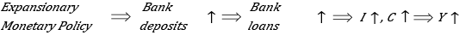

Suppose that CB decides to purchase government bonds. This additional demand for bonds would cause an increase in bond price and a decrease in bonds return $i^{B}$. Money supply rises and LM curve shifts to the right (down). Hence $\frac{∂L^{S}}{∂i^{B}}<0$ lower bonds interest would increase supply of loanable funds,therefore increase in loanable funds would reduce loan interest rate and it would trigger an increase in loan demand and investment expenditures so CC curve already would shift to right

Next figure shows the interaction between the CC and LM curves when the central bank carries out **monetary expansion through open market operations**, which causes a shift in the LM curve, from LM0 to LM1, as well as in the CC curve, from CC0 to CC1. In the traditional IS-LM model, an expansionary monetary policy would undoubtedly lead to a decrease in the bond interest rate to a level equal to iIS, while the product would only increase up to yIS. However, as shown in figure the effect of monetary expansion on the product is greater for the credit market, causing the product to grow to a level equal to y1. It should be noted that in the CC-LM model, monetary expansion has uncertain effects on the interest rate, because the value of that expansion will depend on the magnitude of the shifts in the two curves and their respective slopes.

***Expansionary Monetary Policy in Bernanke Blinder Model***

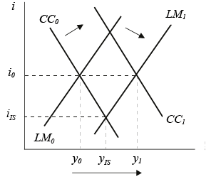

As a consequence of the policy inducedshift of the CC curve, expansionary monetary policy affects *y* twice because the curvesshift in the same direction, i.e. outward.. Hence, Bernanke and Blinder [1988: 437] state *“[…] that the existence of thecredit channel makes monetary policy more expansionary than in IS/LM […]”*.

Consequently, contractionary monetary policy impacts on the LM and CC curve, pushingthe curves inward and, thus, reducing *y* more than in IS/LM. The figure at below illustrates thisaspect. A tight monetary policy operation shifts the CC0 curve to CC1 and the LM0 curveto LM1. The resulting equilibrium brings about yCC. In the textbook IS/LM model, contractionary monetary policy shifts only the LM curve inward and the IS curve remainsunchanged. We may assume that CC0 is shaped similarly to the IS curve. Thus, incomparison to IS/LM, yCC is more reduced than yIS

***Contractionary Monetary Policy in Bernanke Blinder Model***



If the central bank decide to buy government bonds how will be affected the loan interest rate. We should determine the sign of following derivative.

According to asset liability equivalence for central bank assets.

$$\underset{asset}{\underbrace{B^{CB}}}=\underset{liability}{\underbrace{R}}=ER+RR$$

$$M^{S}=M1=μ\left(\underset{+}{\underbrace{i^{B}}}\right)R=μ\left(\underset{+}{\underbrace{i^{B}}}\right)B^{CB}$$

$$L^{D}\left(\underset{-}{\underbrace{i^{L}}},\underset{+}{\underbrace{i^{B}}},\underset{+}{\underbrace{y}}\right)-λ\left(\underset{+}{\underbrace{i^{L}}},\underset{-}{\underbrace{i^{B}}}\right)\left(1-rr\right) μ\left(\underset{+}{\underbrace{i^{B}}}\right)R=L^{D}\left(\underset{-}{\underbrace{i^{L}}},\underset{+}{\underbrace{i^{B}}},\underset{+}{\underbrace{y}}\right)-λ\left(\underset{+}{\underbrace{i^{L}}},\underset{-}{\underbrace{i^{B}}}\right)\left(1-rr\right) μ\left(\underset{+}{\underbrace{i^{B}}}\right)B^{CB}$$

$$\frac{di^{L}}{dB^{CB}}=-\frac{\frac{∂Ψ}{∂B^{CB}}}{\frac{∂Ψ}{∂i^{L}}}=-\frac{\underset{-}{\underbrace{-λ\left(\underset{+}{\underbrace{i^{L}}},\underset{-}{\underbrace{i^{B}}}\right)\left(1-rr\right) μ\left(\underset{+}{\underbrace{i^{B}}}\right)}}}{\underset{-}{\underbrace{\underset{-}{\underbrace{\frac{∂L^{D}}{∂i^{L}}}}-\underset{+}{\underbrace{\frac{∂λ}{∂i^{L}}}}\underset{+}{\underbrace{\left(1-rr\right) μ\left(\underset{+}{\underbrace{i^{B}}}\right)B^{CB}}}}}}<0$$

Mishkin (2004, s. 380, 392)claims that, for any bank, the cost of holding excess reserves is its opportunity cost, the**interest that could have been earned on loans or bonds.** if they had been held instead of excess reserves.

$$e\left(\underset{-}{\underbrace{i^{B}}},\underset{-}{\underbrace{i^{L}}}\right)$$

So we can add the IOER (interest on excess reserve) as a new determinant for excess reserves. If it is positive it will be gain of the commercial bank. But if it is negative like in Europa, it can be another opportunity cost factor

$$e\left(\underset{-}{\underbrace{i^{B}}},\underset{-}{\underbrace{i^{L}}},\underset{+}{\underbrace{i^{ER}}}\right)$$

If $i^{B}$ or $i^{L}$ increases, the opportunity cost of holding excess reserves rises, and the desired ratio of excess reserves to deposits falls. On the other hand an incrase in $i^{ER}$ would encourage them to hold more excess reserves.

***The banking system’s excess reserves ratio is negatively related to the market and loan interest ratesand positively related to the IOER***

*Let’s focus on the effects of market interest rate $i^{B}$ on excess reserves*

$$μ_{1}=\frac{1+c}{rr+e\left(i^{B}\right)+c}$$

$$\frac{∂μ_{1}}{∂i^{B}}=\underset{-}{\underbrace{\frac{∂μ_{1}}{∂e}}}\underset{-}{\underbrace{\frac{∂e}{∂i^{B}}}}=\underset{-}{\underbrace{\frac{-\left(1+c\right)}{{\left(rr+e\left(i^{B}\right)+c\right)}^{2}}}}\underset{-}{\underbrace{\frac{∂e}{∂i^{B}}}}>0$$

Mishkin supports his assertion about positive relationship between the interest rate and excess reserve ratio with following graph.



According to Mishkin money supply function should be upward sloping

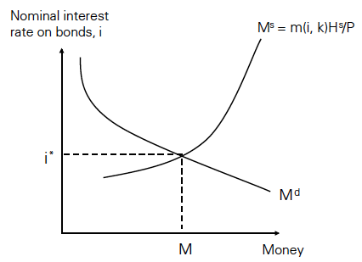

1. There are, in reality, many different kinds of interest rates, because there are many different kinds of loans—shortterm loans, long-term loans, loans made to corporate borrowers, loans made to governments, and so on. In the interest of simplicity, we’ll ignore those differences and assume that there is only one type of loan.